**How to “rugby” – cheat sheet for new players By Anna :)**

**7s rugby**: 7 players on each side, playing 2x 7 mins

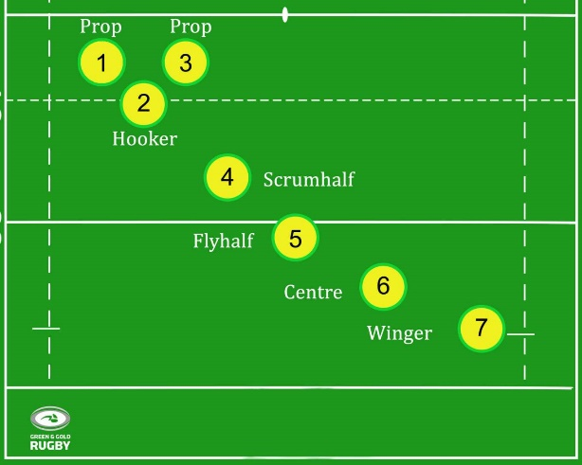

**3 forwards** (2 props, 1 hooker)

* strong, literally do the dirty work, bigger muscles, slower

**4 backs** (scrumhalf, flyhalf, centre, wing)

* faster, good handling, nicer hair, bigger attitude

In 7s rugby the differences are not necessarily as pronounced as in 15s rugby

**Most important basic rules:**

* You can run with the ball in all directions
* The ball must be **passed backwards** otherwise it is a forward pass 🡪 penalty and makes the forwards grumpy as they will have to go into yet another scrum (see next page)
* The ball may be **kicked** forward
* You score a try by placing the ball in a controlled manner in the try zone 🡪 5 points
* After a try, the scoring team will then kick for conversion in a direct line from where the ball was placed for the try (the ball must go through the posts 🡪 2 points
* The scoring team then kicks off play

**Attack setup**

* When we attack we want to stay behind the ball so players can pass to us without making a forward pass
* Stay deep, support the ball carrier when they’re close to you 🡪 run with them, be available for an offload (a short pass after a person’s been tackled), be ready to ruck

**Defense setup**

* In defense we want to stay in one line
* Each player has one opposing player, let others know who your opposing player is
* Try not to break the line, trust that the player next to you will do the tackle
* If they miss the tackle, dishonor on their cow! Try to get the tackle yourself then

**Tackling**

*“The most important thing about tackling is to do the tackle”* – Coach Christopher

Other (also kinda important rules)

* Tackle beaneath the shoulder otherwise it’s a high tackle 🡪 yellow card gets you sent off the pitch for 2min putting the team at a disadvantage
* The lower the better
* Grab tight around the knees/legs and squish them together
* Same leg and shoulder go in first (right shoulder = right leg)
* Your head should be on top of the player
* Tighten your muscles and stay stiff until the other player is down

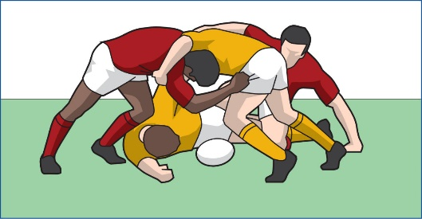**Rucks** (what happens after someone has been tackled)

If your player was tackled:

* Ball should be placed between their feet (ball can only be taken out of the ruck through this „tunnel“ not from the sides)
* Hands on the person on the ground, but you must support your own weight
* Shoulders higher than hips, back straight, head is the extension of the back
* When the opponent comes in: push against them

If the other player was tackled 🡪 try to jackal the ball (“steal” it)

* Can be done if no ruck has been formed yet, so if there’s no support for the tacklee get over the tacklee and grab the ball bringing it securely to your chest
* If you were the tackler: you have to be on your feet first and show your free arms
* 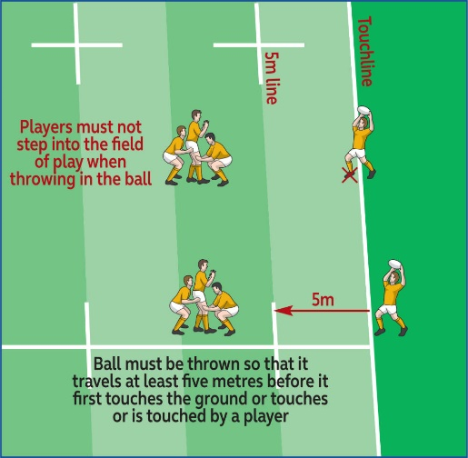If a ruck has been formed, try to clear the ruck by pushing against the supporting player

**Lineouts**

* Happen when the ball leaves the pitch
* The team who kicked/passed/let it fall outside loses possession of the ball, the other team will throw it in from behind the side line
* We can but don’t have to lift a player to catch the ball

**Scrums**

* Happen after a knock-on (so when the ball touches a person’s hands/arms and goes forwards)
* The opposing props and hooker compete over the ball
* The scrumhalf will throw the ball in, the props push, the hookers tries to get the ball out with their foot to their team’s side
* Commands:
  + Crouch: squat like position
  + Bind: props will grab the opposing prop’s jersey
  + Set: scrum attaches, head always goes to the left
* 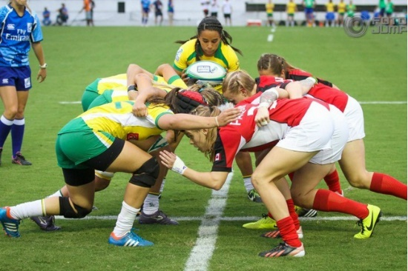Pushing happens only after the ball is in